

|  |  |  |  |  |  |  |  |  |
| --- | --- | --- | --- | --- | --- | --- | --- | --- |
|  | | | | | | | | |
|  | | Capstone Project – NORTHWIND SALES ANALYSIS | | | | |  | |
|  |  | | | | | | |  |
|  | | | |  |  | | | |
|  | | | | ARUN PENTABOYINA |  | | | |
|  | | | | —Data Analytics—Arun Pentaboyina |  | | | |
|  | | |  | | |  | | |



|  |  |  |  |  |  |  |  |  |
| --- | --- | --- | --- | --- | --- | --- | --- | --- |
|  |  | | |  |  | | |  |
|  | Overview | | | | | | |  |
|  |  | | |  |  | | |  |
|  |  | |  | | |  | |  |
|  |  |  | The report aims to generate insights into customer behavior, sales patterns, and employee performance to aid decision-making processes. It will cover sales analysis, customer segmentation, inventory trends, and employee performance, consolidating data from multiple tables for a comprehensive view of the company's operations. The report will empower stakeholders to make data-driven decisions by offering valuable insights and facilitating data exploration through interactive visualizations and dynamic filters. The expected impact is to revolutionize how Northwind Traders interacts with its data, enabling the company to remain competitive and drive its business forward in the wholesale market landscape. | | |  |  |  |
|  | | | | |
|  |  |  |  |
|  |  |



|  |  |  |  |  |  |  |
| --- | --- | --- | --- | --- | --- | --- |
|  | |  |  |  |  | |
|  | | THE PROCESS | | |  | |
|  | |  |  |  |  | |
|  | 1. Data Acquisition from GitHub:  Obtain the requisite dataset from a designated GitHub repository, containing essential information on university rankings, encompassing various countries and their performance across distinct ranking systems.  2. Data Transformation and Enhancement:  If necessary, execute data transformation procedures to ensure data quality and consistency. Additionally, consider augmenting the dataset with new problem statements to enrich the analysis potential.  3. Connecting with Tools:  Establish connections between the dataset and various analytical tools. Interface the dataset with Power BI, Excel, and MySQL Workbench, facilitating seamless data integration and processing.  4. Problem Statement Solution in Power BI:  Utilize Power BI to delve into the specified problem statements. Employ its robust features for data visualization, exploration, and analysis, effectively deriving insights and solutions.  5. Exploratory Data Analysis (EDA):  Perform exploratory data analysis using either Excel or SQL Workbench, depending on the complexity of the analysis. Extract meaningful patterns, relationships, and trends from the data to inform subsequent decision-making.  6. Creation of Visual and Insightful PowerPoint:    Develop a comprehensive PowerPoint presentation that encapsulates the project's objectives, methodologies, problem statement solutions, and key visualizations. Each problem statement should be accompanied by a dedicated section with pertinent conclusions and insights.  7. Detailed Documentation:  Compile a detailed report that meticulously documents the entire project lifecycle. Include sections on data collection, transformation, problem statement formulation, tools integration, Power BI solutions, EDA insights, and PowerPoint visualizations. | | | | |  |

**Objective**

Sales performance is a critical metric for understanding business growth, customer behavior, and product trends. Analyzing historical sales data provides valuable insights into what drives revenue, customer loyalty, and market success. This project focuses on an in-depth analysis of the **Northwind sales dataset**, a sample data source commonly used to model real-world retail operations.

The **objective** of this project is to perform a **comprehensive sales analysis** to identify key trends, product performance, customer patterns, and operational metrics across time, geography, and category dimensions. The goal is to derive actionable insights that can help businesses optimize strategies, boost revenue, and enhance customer engagement.

The project will involve the following tasks:

* Analyzing historical sales trends over time (monthly/seasonal patterns).
* Identifying top-performing products, categories, and regions.
* Exploring customer segmentation based on spend, frequency, and behavior.
* Evaluating shipping performance and order handling durations.
* Detecting anomalies or outliers in revenue and product demand.

The success of the project will be measured by the following metrics:

* Depth and clarity of analysis
* Relevance and accuracy of business insights
* Interactivity and usability of the Power BI dashboard

This project is significant because it demonstrates how structured data can be leveraged to support data-driven decision making in business. Organizations can use such insights to: Forecast demand more accurately ,Improve customer retention strategies , Optimize inventory and supplier relationships , Increase overall operational efficiency  
By understanding key sales drivers and performance indicators, businesses can stay competitive in a fast-paced, customer-focused marketplace.

**Significance**

Sales analysis plays a pivotal role in modern business strategy, offering valuable insights to decision-makers, marketers, and operations teams. By thoroughly examining historical sales data, businesses can better understand performance trends, customer behavior, and product dynamics—ultimately supporting informed, data-driven decisions. Let’s explore the significance of sales analysis in greater detail:

Sales analysis provides clarity on **what drives revenue**, enabling strategic planning based on real performance rather than assumptions. Executives can identify high-performing product categories, profitable customer segments, and seasonal trends. This allows for **better forecasting**, **inventory planning**, and **targeted business growth strategies**. In the context of this project, analyzing Northwind’s historical data enables simulation of real business scenarios and strategic recommendations.

Understanding sales trends helps marketers craft **personalized campaigns** and **optimize promotions**. By analyzing customer segments based on order frequency and spend, teams can identify loyal customers and create retention strategies. Product-level analysis helps in **refining inventory**, pricing strategies, and targeting the right audience at the right time. For instance, identifying which products perform best in which regions empowers more focused marketing efforts.

By tracking order handling time, shipping durations, and supplier performance, the organization can identify **bottlenecks and inefficiencies** in its supply chain. A detailed analysis allows businesses to adjust procurement strategies, negotiate with suppliers, and improve delivery timelines—all contributing to better customer satisfaction and cost savings.

In an increasingly competitive market, businesses must continually **benchmark performance** and **adapt to changing trends**. Insights from sales analysis help companies remain agile, adjusting their operations, pricing, and strategies based on real-time data. This project demonstrates how a company—even modeled through a dataset like Northwind—can use data visualization and BI tools (like Power BI) to scale its operations intelligently.

This project promotes a culture of **data literacy** and **accountability** by showcasing how raw data can be converted into actionable intelligence. Dashboards designed in Power BI empower all stakeholders—from analysts to executives—to explore insights interactively and independently. This improves cross-functional communication, reporting clarity, and transparency across departments.

**In Conclusion**

The **Sales Analysis Project** not only demonstrates the power of data analytics but also reflects how such tools can transform business operations. It enables stakeholders to understand what’s working, what’s not, and where to focus next. By leveraging structured data and modern BI tools, organizations can become more **customer-centric**, **efficient**, and **competitive**, ensuring long-term success in a dynamic market environment.

**Data Dictionary:**

**Table: Customers**

* **Fields:**
  + CustomerID: Unique identifier for each customer.
  + CompanyName: Name of the customer’s company.
  + ContactName: Name of the contact person.
  + Country: Country where the customer is located.
  + City: City of the customer.
  + PostalCode: Postal code of the customer’s address.

**Table: Orders**

* **Fields:**
  + OrderID: Unique identifier for each order.
  + CustomerID: Foreign key referencing the CustomerID field in the Customers table.
  + OrderDate: Date on which the order was placed.
  + ShippedDate: Date on which the order was shipped.
  + ShipCountry: Country to which the order was shipped.
  + ShipCity: City to which the order was shipped

**Table: OrderDetails**

* **Fields:**
  + OrderID: Foreign key referencing the OrderID field in the Orders table.
  + ProductID: Foreign key referencing the ProductID field in the Products table.
  + UnitPrice: Price per unit of the product at the time of order.
  + Quantity: Number of units ordered.
  + Discount: Discount applied to the order item (in decimal form, e.g., 0.1 for 10%).

**Table: Products**

* **Fields:**
  + ProductID: Unique identifier for each product.
  + ProductName: Name of the product.
  + CategoryID: Foreign key referencing the CategoryID in the Categories table.
  + UnitPrice: Price per unit of the product.
  + UnitsInStock: Number of units available in stock.

**Table: Categories**

* **Fields:**
  + CategoryID: Unique identifier for each product category.
  + CategoryName: Name of the category (e.g., Beverages, Confections).
  + Description: Description of the product category.

**Table: Employees**

* **Fields:**
  + EmployeeID: Unique identifier for each employee.
  + LastName: Last name of the employee.
  + FirstName: First name of the employee.
  + Title: Job title of the employee.
  + Country: Country where the employee is based.
  + City: City of the employee's location.

**Table: Shippers**

* **Fields:**
  + ShipperID: Unique identifier for each shipping company.
  + CompanyName: Name of the shipping company.
  + Phone: Contact number of the shipper.

The data dictionary provides a comprehensive overview of the tables and their respective fields in the dataset. It outlines the relationships between the tables, allowing for a better understanding of the data structure and facilitating the design and implementation of the Power BI Dashboard.

**ER Diagram**

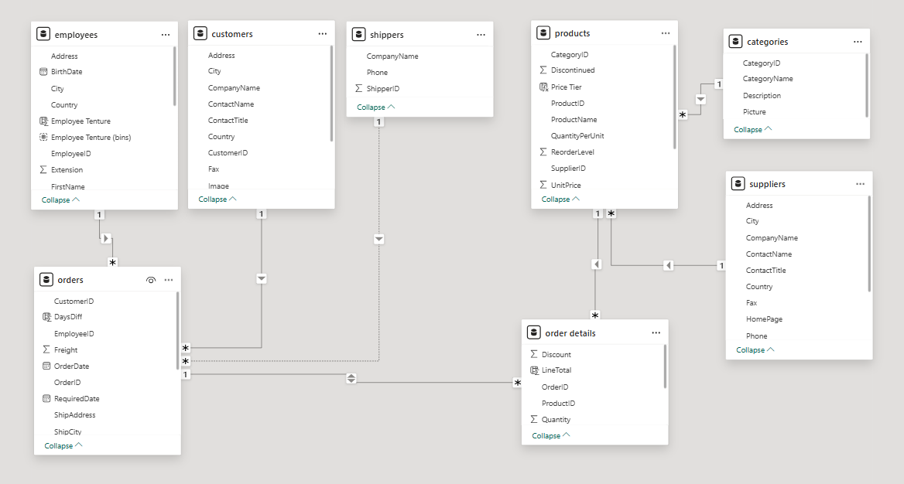

**Power BI Problem Statements**

**[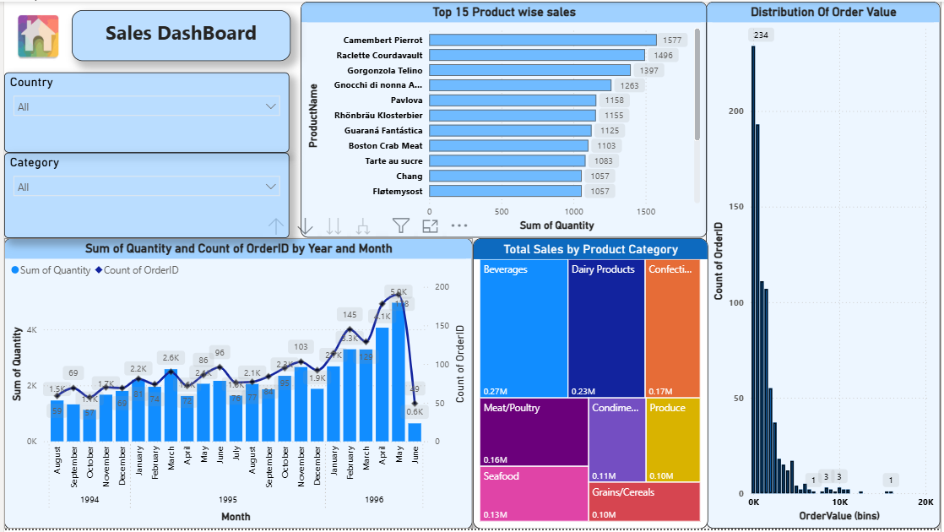](https://app.powerbi.com/groups/me/reports/f055a63d-eada-463a-802a-2957e30805e8/?pbi_source=PowerPoint)**

How does customer distribution vary across different countries or cities? Use bar chart or map to visualize.

Based on the "Country wise customers" bar chart provided, customer distribution varies significantly across different countries. The **USA** has the highest number of customers with 13, closely followed by **France** and **Germany**, each with 11 customers. **Brazil** comes next with 9 customers, and the **UK** has 7. Countries like **Mexico, Spain, and Venezuela** have a moderate number of customers, each with 5. Further down, countries such as **Argentina, Canada, Italy, and Austria** have fewer customers, ranging from 3 to 4. Finally, a long tail of countries including **Belgium, Denmark, Finland, Portugal, Sweden, and Switzerland** each have 2 customers, while **Ireland, Norway, and Poland** have the lowest count with just 1 customer each. This visualization clearly indicates a concentrated customer base in a few key countries, with a rapid decline in customer numbers for the majority of other nations.

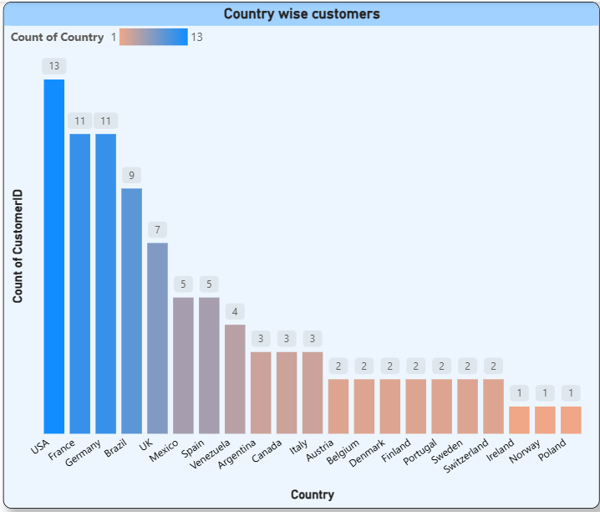

What is the trend in customer orders over time? Use line chart or area chart to visualize.

The trend in customer orders over time, as depicted in the "Monthly wise orders trend" chart, shows a general increase from **October 1994 to May 1996**, followed by a sharp decline in **July 1996**.

Starting from just 1 order in **September 1994**, orders gradually increased, reaching 25 in **October 1994**. There were minor fluctuations, but the trend was upward, reaching 34 orders in **May 1995** and 40 in **October 1995**. The peak was observed in **May 1996** with 73 orders, indicating a significant growth period. However, this growth was not sustained, as orders plummeted to 13 in **July 1996**.

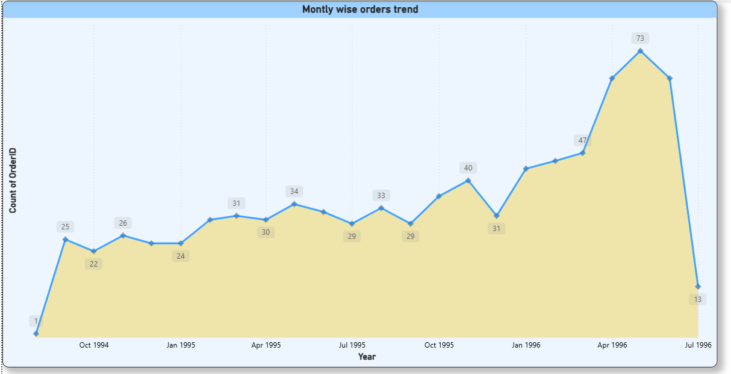

What is the distribution of customers by Contact Title or Region? Use stacked bar chart or pie chart to visualize.

Based on the provided visuals, customer distribution by contact title is led by "Owner" and "Sales Representative" (each with 17 customers), followed by "Marketing Manager" (12), "Sales Manager" (11), and "Accounting Manager" (10), with other titles having significantly fewer customers. Concurrently, the regional customer distribution is heavily skewed, with the "SP" region accounting for a dominant 60 customers, while all other listed regions have a very small number of customers, ranging from 1 to 4.

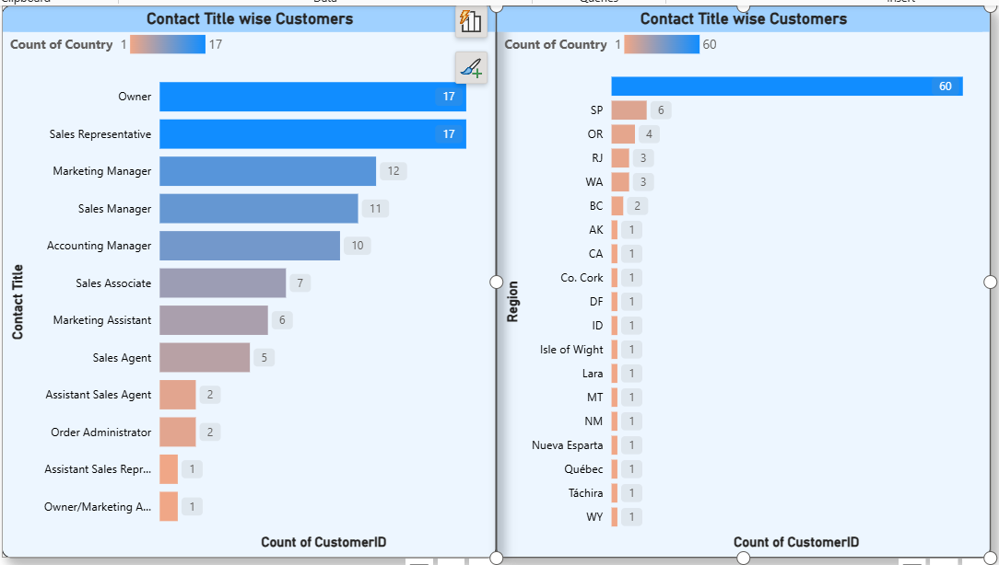

How does order volume change over time? Use line chart or stacked bar chart to visualize.

The provided "Sum of Quantity and Count of OrderID by Year and Month" chart reveals a significant trend in order volume: starting with low figures in August 1994, both the sum of quantity and the count of order IDs showed a general, though fluctuating, increase through late 1995 and into early 1996, peaking dramatically in May 1996 with 5.0K in quantity and 191 orders. However, this growth was abruptly followed by a sharp decline in June 1996, where both metrics plummeted to 0.6K in quantity and 50 orders, indicating a significant, sudden reversal in order volume..

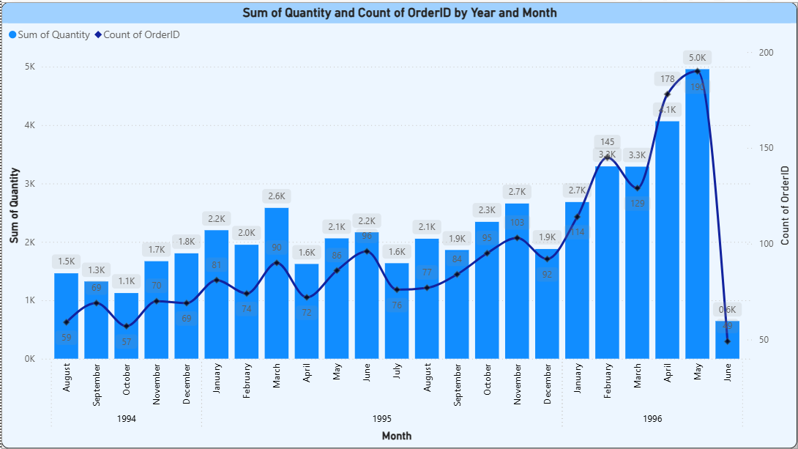

What is the count of employees by job title or region? Use stacked bar chart or tree map to visualize.

Based on the "Count of EmployeeID by Title" tree map provided, the distribution of employees by job title is as follows: **Sales Representative** is the most numerous title with **6 employees**. Following distantly, **Inside Sales Coordinator**, **Sales Manager**, and **Vice President, Sales** each have **1 employee**. No information on employee count by region is provided in the given visuals

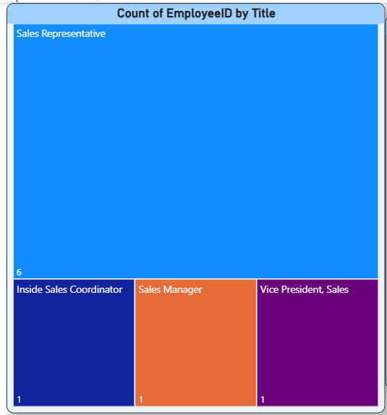

THE BELOW ARE FROM EDA

What is the average number of orders per customer? Are there high-value repeat customers?

For EDA, the average number of orders per customer is 9.1209. Furthermore, the analysis clearly identifies high-value repeat customers, with QUICK-Stop, Ernst Handel, and Save-a-lot Markets standing out due to their exceptionally high total spent values ($110,277.30, $104,874.98, and $104,361.95 respectively) and significant order counts, indicating a strong base of loyal, high-contributing customers.

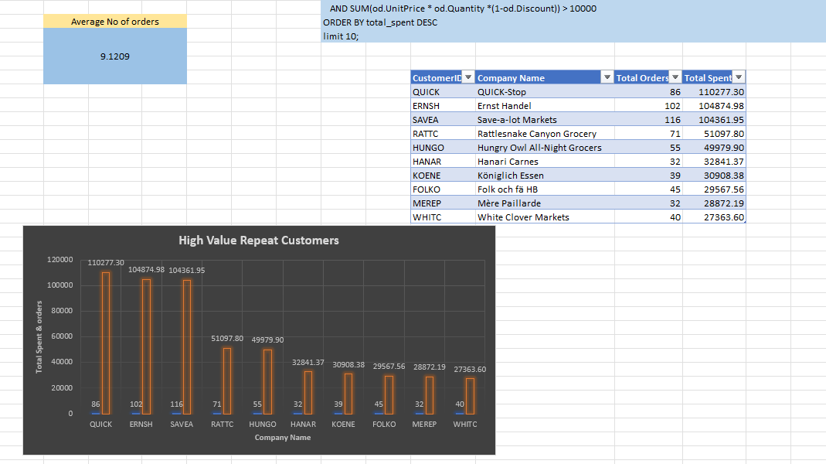

How do customer order patterns vary by city or country?

Customer order patterns vary significantly by country, with the **USA, France, and Germany** consistently showing higher customer counts and total orders. Specifically, the **USA leads in customer numbers (13)**, while **Germany (328 orders)** and the **USA (352 orders)** have the highest total order volumes. Countries with more customers also generally exhibit higher average sales, indicating a concentrated and more active customer base in these regions, whereas no city-specific data is provided.

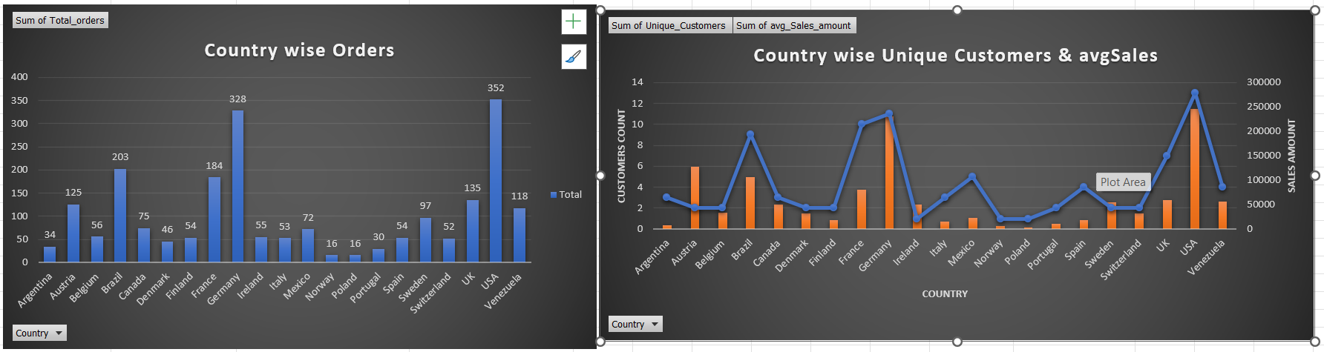

Which product categories or products contribute most to order revenue?

Beverages and Dairy Products are the top-contributing product categories, generating $267,868.18 and $245,077.20 in revenue respectively. Among individual products, Côte de Blaye stands out significantly as the highest revenue contributor with $141,396.73, followed by Raclette Courdavault with $71,155.77.

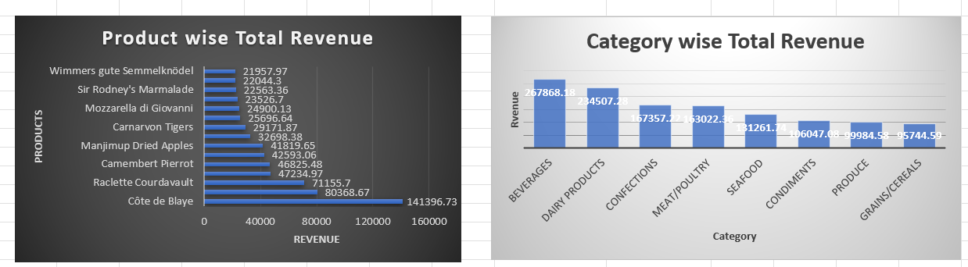

What trends can we observe in hire dates across employee titles?

Analyzing the "Title Wise Count" chart and the accompanying table, we can observe that Sales Representatives were hired over a period up to November 1994, constituting the largest group of 6 employees, suggesting a significant expansion or focus on sales at that time. In contrast, Inside Sales Coordinator, Sales Manager, and Vice President, Sales each have only 1 employee, with their hire dates ranging from March to October 1993 and August 1992 respectively, indicating a more staggered and less numerous hiring trend for these specific management and coordination roles compared to the Sales Representative position..

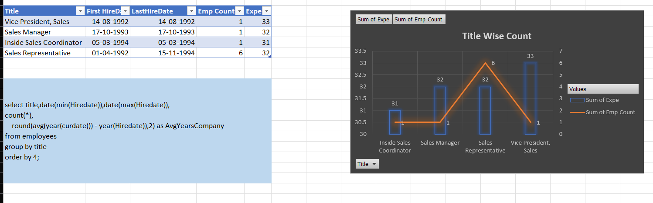

What patterns exist in employee title and courtesy title distributions?

From the "Title vs Courtesy" chart and the accompanying analysis, it's evident that a significant pattern exists in employee title and courtesy title distributions: **higher-level roles such as Sales Manager and Vice President, Sales are predominantly held by men (indicated by "Mr." courtesy title)**, suggesting a gender imbalance in leadership. Conversely, **mid-level roles like Sales Representative show a more diverse mix of male and female employees**, with both "Mr." and "Ms." represented. Additionally, there appears to be a complete absence of employees with academic titles like "Dr.", implying that the majority of the workforce comes from business or sales backgrounds rather than technical or research fields, which could be a strategic area for diversification if the company aims for growth in research or innovation.

.

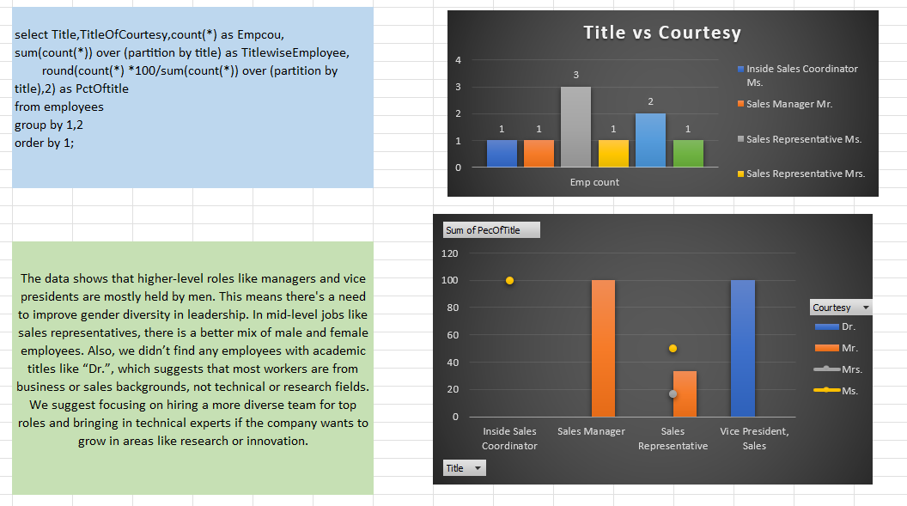

POWERBI Report Snap shots

[](https://app.powerbi.com/groups/me/reports/f055a63d-eada-463a-802a-2957e30805e8/?pbi_source=PowerPoint)

[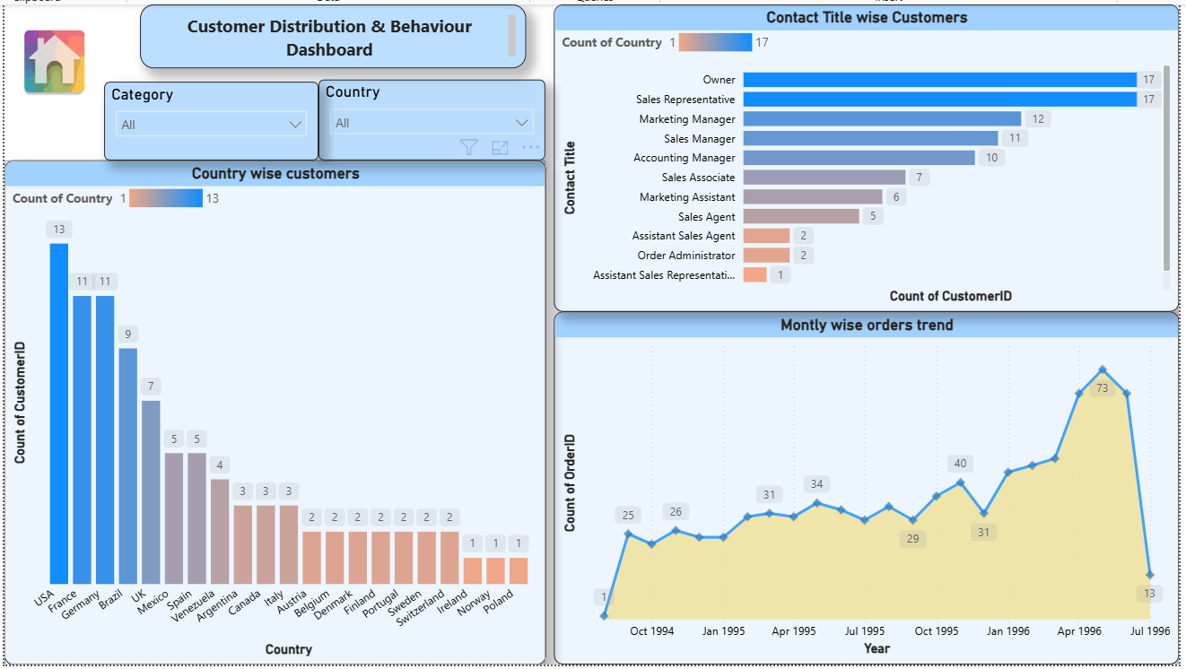](https://app.powerbi.com/groups/me/reports/f055a63d-eada-463a-802a-2957e30805e8/?pbi_source=PowerPoint)

[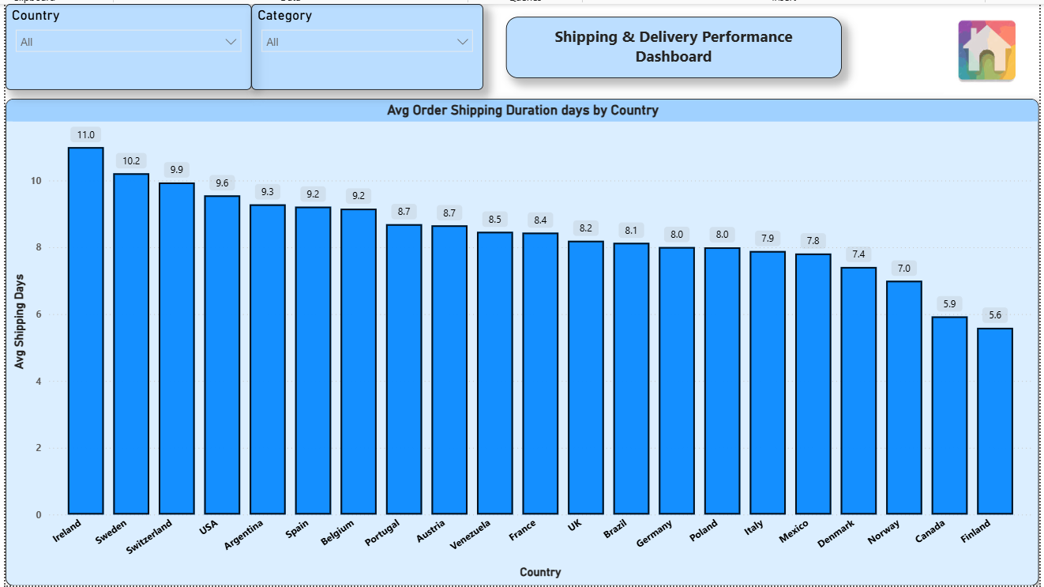](https://app.powerbi.com/groups/me/reports/f055a63d-eada-463a-802a-2957e30805e8/?pbi_source=PowerPoint)

[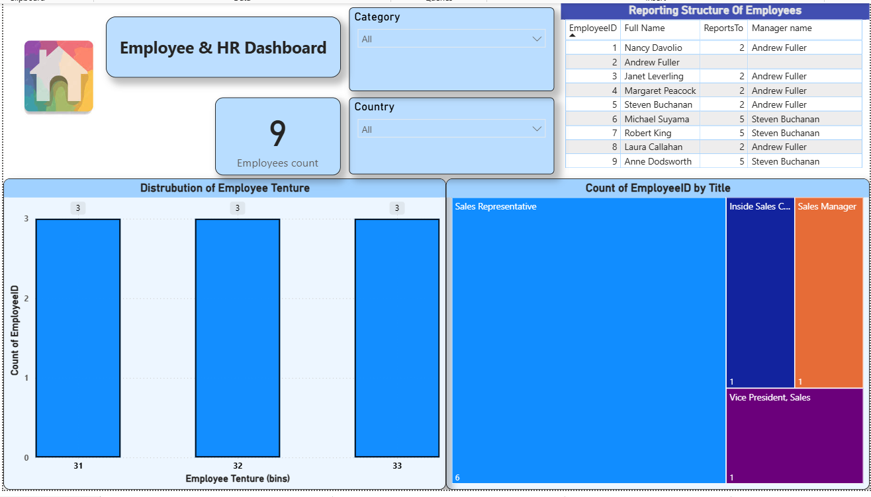](https://app.powerbi.com/groups/me/reports/f055a63d-eada-463a-802a-2957e30805e8/?pbi_source=PowerPoint)

[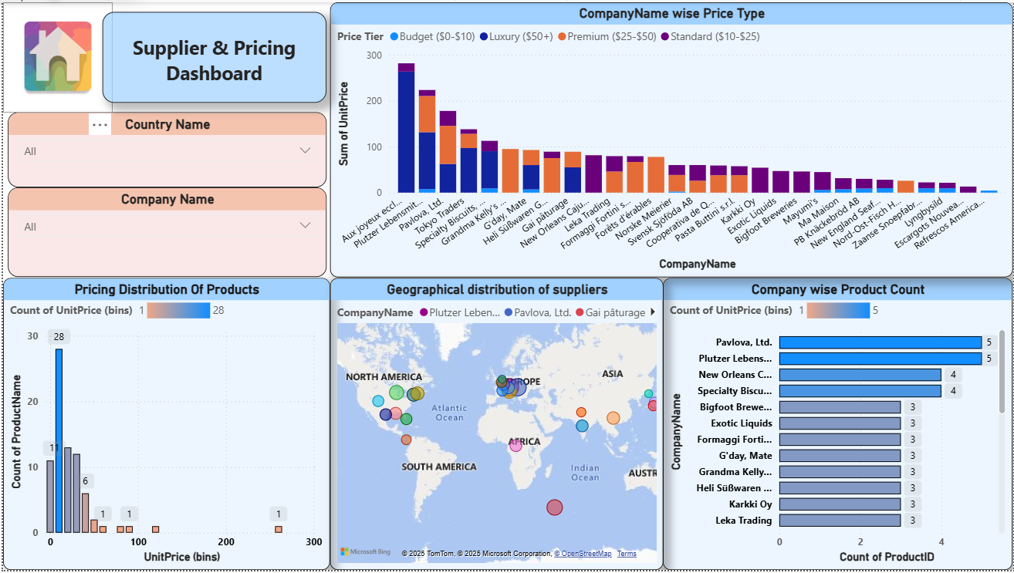](https://app.powerbi.com/groups/me/reports/f055a63d-eada-463a-802a-2957e30805e8/?pbi_source=PowerPoint)